Block Flow Diagram and Supplemental Data Instructions and Overview:

NOTE: The Block Flow Diagram (BFD) & Supplemental Data (SD) template is provided as a convenient method of documenting the information required to accurately assess the projects proposed in response to this FOA. The use of the BFD & SD template is not required, but the data elements presented within the BFD & SD template are required.

Instructions and Overview:
The purpose of the BFD & SD is to assess the merits of the selected technology and the status of the process technology in order to gain an understanding of project risks and the potential viability of the proposed project. Please answers all questions as thoroughly as possible based on current knowledge.

Please provide a BFD (a simplified example of a BFD can be found at the end of this PDF) for the entire envisioned process, from feedstock handling through final biofuel or product storage. Please indicate, with a dotted lined circle, which unit operation(s) will be the subject of the proposed project. Similarly, please provide the filled out Supplemental Data Template (or equivalent data) for the unit operation(s) that will be the subject of the proposed project.

It is expected that applicants describe previously collected data from their (a) existing process (lab-, bench-, or other-scale) that will be utilized during the proposed project to design and build the (b) proposed equipment / unit operations, which in turn will be used to gain process information to design, construct, and operate a (c) fully integrated facility post project. Pay particular attention to the proposed engineering-scale equipment when answering the questions below for each unit operation. The attached BFD & SD should relate to the proposed project.

Unit Operation Step: Unit operation steps are defined as the areas in the facility where a change occurs, such as reactions, physical changes to materials including materials handling, or chemical conversions. (A physical step physically alters material, and a chemical conversion step involves changes in the molecular form of a material.) Some examples of items to be included as unit operation steps appear below:

Reactors Shredder Filters Drying
Distillation Mixers Ion Exchange Fermenters
Aerators Gas Absorption Separations Gas Cleanup

Use a unique number for each unit operation in the BFD. Show recycle loops and waste streams as well. The characteristics of each output should directly tie to input of the respective unit operation in the process. If additional processing is required before the output of one unit can be used as the input to another, an additional unit operation should be included to describe how the stream is altered. It is particularly important to focus on the heat and material balance of each block step. The description of the process should begin with the first manipulation of the feedstock in its as-received condition, such as de-stringing of baled corn stover or any initial sizing/moisture reduction of wood chips. Applicants are encouraged to summarize the process using 10 blocks or fewer for an estimated level of detail.
Block Flow Diagram & Supplemental Data Template
Provide the following information for the entire process shown in the BFD
(approximate length 1 - 2 pages)
- How and why was the proposed process chosen? Discuss technical and business risks, benefits and opportunities associated with the process.
- Describe the history of research and development performed by the applicant for the proposed process including scale, duration of runs, type of data collected, etc.

Answer the following questions for each unit operation that has been circled in your BFD
(approximate length 2 - 3 pages per unit operation)
1. Name or title (as shown in the BFD)
2. Description of the PROPOSED unit operation
For each unit operation include operating conditions including (but not limited to):
- Capacity and/or throughput
- Operating Temperature
- Operating Pressure
- Residence Time
- Yields (theoretical and actual)
- Conversion efficiency (theoretical and actual)
- Material(s) of construction for key pieces of equipment
- Expected life expectancy and expected maintenance cycles
- Mode of operation (batch, semi-batch, plug flow, continuous flow, etc.)
- Describe any known causes and the impacts of system upsets and contaminants (including the source(s) of the contaminants)
- Waste Streams
For each unit operation include mass and energy balance information for each process stream entering or leaving the unit operation including (but not limited to):
- Pressure
- Temperature
- Mass Flow Rate
- Composition by mol%
- Phase (gas, vapor, liquid, slurry, solid, etc.)
3. Current state of technology of PROPOSED unit operation
- Is the technology used for this unit operation based on commercially available equipment? If so, is the proposed design and use within the manufacturer’s normal operating parameters?
- Provide the following scale up information
  - What was the previous scale the unit operation / technology has been tested?
  - What is the proposed scale up factor for the unit operation?
    - $Scale Up Factor=\frac{Proposed Scale or Capacity}{Previous Scale or Capacity}$
  - How many tests/runs were performed at the previous scale?
  - What was the longest continuous test/run at the previous scale?
  - When was the most recent test run completed at the previous scale?
  - If previous scale was a result of bench scale R&D, describe the original goals and objectives of the R&D. Summarize the results of the R&D and discuss how the original goals and objectives were met or not met. Describe the quality and replicability of the results. (If data quality objectives were used to set minimum data quality standards, briefly describe them.)
  - Is further R&D required prior to scaling up this unit operation / technology? Describe the goal and summarize the work needed to obtain the needed information.
- Calculate the following sustainability metrics for each unit operation commenting on both the values observed to date as well as targets for the envisioned commercial-scale facility:
- GHGs (g CO₂-e/MJ fuel) – (emissions)
- Fossil Energy Consumption (MJ fossil energy/MJ fuel product)
- Total Fuel Yield (gal/dry ton wood; GGE/dry ton wood)
- Carbon-to-Fuel Efficiency (C in fuel/C in biomass)
- Water Consumption (m³/day; gal/GGE)
- Wastewater Generation (m³/day; gal/GGE)

Example: Simplified Block Flow Diagram with dotted circle showing unit operations that will be part of the proposed project. Block flow diagram courtesy of NREL (Humbird et. al. 2011, 4)

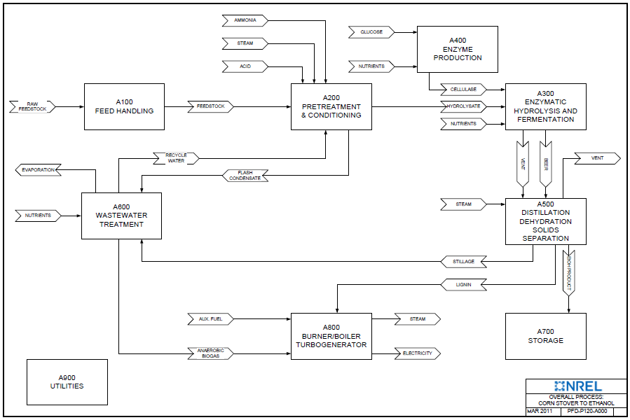

1. Humbird, D.; Davis, R.; Tao, L.; Kinchin, C.; Hsu, D.; Aden, A. Process Design and Economics for Biochemical Conversion of Lignocellulosic Biomass to Ethanol: Dilute-Acid Pretreatment and Enzymatic Hydrolysis of Corn Stover. Report No. NREL/TP-5100-47764. Golden, CO: National Renewable Energy Laboratory, May 2011. https://www.nrel.gov/docs/fy11osti/47764.pdf

